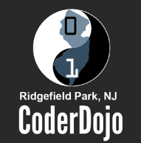

**Did you enjoy today’s session? Here’s what else you can do:**

* Have your parents register you for next month’s session using the library website:

www.RidgefieldParkPublicLibrary.org

NEXT SESSION is Saturday, October 18, 2014 2pm-4pm



* Have your parents “Ridgefield Park CoderDojo”

(For Pictures, News & More)

* Spread the word to all your friends! They may want to join our club, too!

* Ask a librarian to help you find books about “HTML” or “Programming”
* Keep practicing what you’ve learned today. Here are some websites to check out:

[www.Code.org/learn](http://www.Code.org/learn) <https://coderdojo.com/dojo-for-kids/>

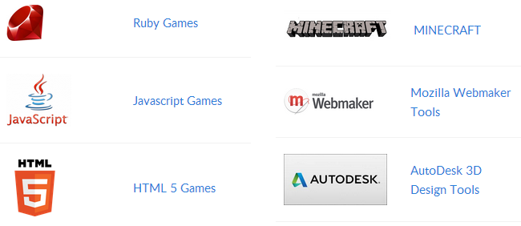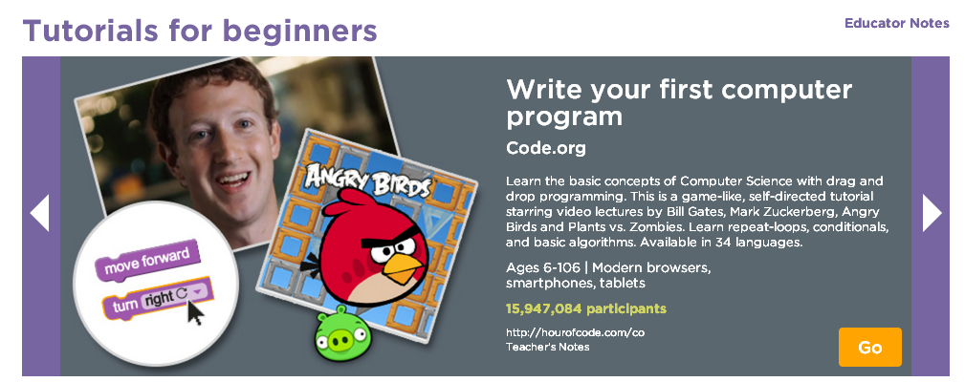

We hope to see you next month… Stay cool and keep on CODING!!!

Champion1 ([champ1 at gmail.com](mailto:ARNIEforte@gmail.com))

Champion2 ([champ 2 at gmail.com](mailto:anabelleforte@alum.rpi.edu))